**Topic 1 – Intelligent Agents**

1. Terminology
   1. **Agent** – anything that can be viewed as perceiving its **environment** through **sensors** and acting upon that environment through **actuators**.
      1. ??? – Using that definition, name some agents that exist in any game, computer system, etc.
         1. Pacman ghosts act as agents, Tesla car
         2. NPC’s
         3. Siri
   2. **Percept** – perceptual inputs…how the agent gets information from the environment.
      1. ??? – Using the examples from before, what would the percepts of those agents be?
         1. Sight, sound
   3. **Actuators** – the tools the agent uses to take action in the environment.
      1. ??? – What are those agent’s actuators?
         1. Roomba moves with wheels and cleans
         2. Robots use hands and feet or legs to move in its environment
   4. **Agent Function** – specifies the action taken by the agent in response to any percept sequence. Illustrated by the figure below:
      1. Roomba sees a wall and decides to rotate to avoid wall

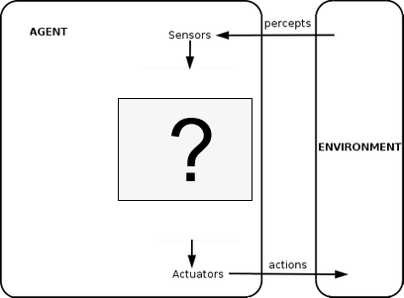

* 1. Vacuum cleaner world – a (very) simple example. p.36
     1. Look at figure 2.2 and 2.3
  2. **Environment State** – a snapshot of the characteristics of the environment
     1. ??? – environment states in the vacuum cleaner world?
        1. Mars Rover – current position, temperature, time of day, position of rovers arms and legs
        2. Vacuum cleaner
           1. Tile A is dirty, tile B is dirty
  3. **Percept Sequence** – the entire history of what the agent has perceived.
     1. Listing of all the previous states

1. Behavior
   1. Agents are rational if they seek to do the “right” thing.
      1. ??? – what does it mean to do the right thing?
         1. To do what aligns with the rules set by the creator.
      2. ??? – How do we evaluate whether an agent did the right thing?
         1. If the agent follows the rules of the program.
   2. **Performance measure** – how a series of environmental states are evaluated. An agent selects an action/series of actions, and each action will cause the environment’s state to change.
      1. How we determine if the agent is doing the right thing
         1. Vacuum world – how clean the floor is.
      2. *When you’re coming up with your own performance measures, it’s better to design with the desired outcome in mind, rather than how you think the agent should act.*
         1. Focuses on root of the problem rather than smaller details.
            1. Example: Daughter isn’t cleaning up her toys and is arguing so rather than addressing the act of arguing, address the act of disobedience
   3. **Rational Agent** – (book definition) – for each possible percept sequence, a rational agent should select an action that is expected to maximize its performance measure, given the evidence provided by the percept sequence and whatever built-in knowledge the agent has.
      1. Vacuum world
         1. Tile A is clean, and B is clean, the vacuum should turn off.
         2. If cleanliness is valued over electricity, go back to A.

**Summary: Rational agents seek to do the right thing. The right thing is defined by the performance measure.**

1. Discussion – Mario-NES style! Let’s say we’ve been tasked with rewriting the AI script for the enemies in Mario.
   1. Define the environment and what the agent (enemy) knows/can perceive
      1. Mario Goomba
         1. Can sense Mario.
         2. Can sense other objects.
   2. What are the “right” actions for the agent to take?
      1. Increase walking speed
      2. Move towards where Goomba thinks Mario will be
      3. FOCUS ON GOALS AND LET ACTIONS NATURALLY COME
   3. Define a performance measure
      1. Look at what Goomba just did (past 10 actions)
         1. Moving closer to Mario is good + 1 point
         2. Moving away from Mario is bad – 100 points
         3. If Mario is right above Goomba – 50 points
   4. Is the agent rational? How do we know?
      1. If each action it takes sustains the performance measure
2. Discussion…back to the vacuum world (p. 38). Let’s say:
   1. *Performance measure gives one point for each clean square at each time step, over a period of 1000 time steps.*
   2. *The bounds/geography of the environment is known, but the dirt distribution and initial location of the agent are not.*
   3. *Agent actions: left, right, clean(suck)*
   4. *The agent can correctly perceive its location and whether that location contains dirt.*
   5. Ok – using those rules, would you say that the agent is rational? Justify your answer!
      * 1. We know that a rational agent seeks to do the “right” thing.
        2. The “right” thing is defined by the performance measure
        3. This performance measure awards points based off of the number of clean tiles
        4. The agent’s actions seek to do that = rational
   6. ??? – What will the agent do once all the squares are cleaned? Is that rational?
      1. Seek out new locations or remain idle if all known squares are cleaned
   7. What if we changed the performance measure to include a loss of a point for each movement (left/right) that was made? Would the agent still be rational?
      1. Yes
3. Break
4. Quick Review

|  |  |  |  |  |
| --- | --- | --- | --- | --- |
| Agent Type | Performance Measure | Environment | Actuators | Sensors |
| Taxi Driver | Safe, fast, legal, comfortable trip, maximize profits | Roads, other traffic, pedestrians, customers | Steering, accelerator, brake, signal, horn, display | Cameras, sonar, speedometer, GPD, odometer, accelerometer, engine sensors, keyboard |

* 1. This table is known as a PEAS description.
  2. There are additional PEAS descriptions on page 42.

1. Independent practice
   1. Open the ‘Dodgeball Game.exe’ file under the Topic 1 – Intelligent Agents Module on Canvas
   2. Establish known information (information that the agents can perceive/know)
      1. Can’t move past the line.
      2. Know where the balls are.
      3. Know where the players are.
      4. Know to dodge balls flying towards them.
      5. Know when the player is charging a throw.
   3. Write a performance measure for the agents in the game
      1. If the ball is in the agent’s side of the court, the agent will go to pick up the ball.
      2. Modify aggression to match players left on team
      3. Subtract points for being in line of fire
         1. But if the other team has the last player, then the agent is awarded points
      4. Lose points for throwing ball but award more points for accuracy
      5. If without a ball, rewarded points for being closer to a ball
      6. Award points for more balls being on agents’ side of the court
      7. Award points for throwing a ball and throwing a ball at someone
      8. Award points for blocking ball
   4. Based off of your performance measure, are the agents rational?
      1. Yes, for the most part. One agent acted greedy in a 1v1 situation that caused them to lose.
2. **Omniscience** – Knowing the *actual* outcome of actions instead of the *expected* outcome.
   1. Rational agents choose actions based off of an expected outcome
   2. Omniscient agents choose actions based off of what they know will happen
   3. Is omniscience impossible in reality? In programs/games?
      1. Reality - It is not completely possible as anything can happen. There are an infinite number of outcomes. Anything in our world is subject to instability.
      2. Programs/games – Looking at the program/game separated from reality, omniscience is possible.
   4. Good test questions – compare contrast the characteristics of omniscient and rational agents
3. Additional characteristics
   1. **Fully vs. partially observable** – do the agent’s sensors give access to the entire environment or just part of it?
      1. Checkers - fully
      2. Poker – partially, do not know what is in the other person’s hand.
      3. Monopoly – partially, do not know Community chest and chance cards
      4. Checkers – fully
      5. Dodgeball game - fully
   2. **Single vs. multi agent** – how many agents exist in the environment. This can be tricky depending on how you classify other agents and how each agent views other agents.
      1. Taxi driver example
         1. Customers are not agents.
      2. Dodgeball – multi agent of similar type in the environment
      3. Vacuum – single agent
      4. **Whether or not the other agents or objects of the environment impact decision making**
   3. **Competitive vs. cooperative** – does an agents behavior maximize its performance while also minimizing other agents?
   4. **Deterministic vs**. **stochastic** – is the next state of the environment completely determined by the current state and action of the agent?
      1. Holding ball, given action to throw
      2. Vacuum cleaner in pile of dirt – will it clean? **Deterministic**
      3. **If there is a chance of failure, then it is not deterministic.**
      4. **Stochastic – randomness or uncertainty.**
         1. Usually, video games are stochastic.
4. **Agent programs**Take the current percept as input from the sensor and return an action to the actuators.



Agent program

1. **Simple reflex agents** – select actions on the basis of the current percept, ignoring the rest of the percept history.
   1. Vacuum agent – its decision is based only on the current location and on whether that location contains dirt.

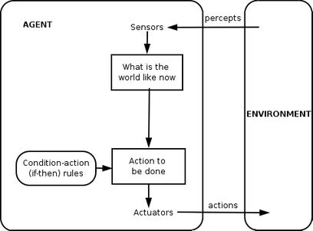

1. **Model-based reflex agents** – makes decisions based off of a model of the world that has been constructed from two types of knowledge:
   1. Knowledge of how the world evolves independent of the agent (so that the agent can keep track of stuff it can’t see right now, but has seen in the past).
      1. “I put my keys in my pocket a while ago. I don’t see them now, but I expect them to be in my pocket still”
      2. “I saw a car in my rearview mirror a few seconds ago. I’m not looking at it now, but I expect that it will be closer to me now than it was when I observed it”
   2. Knowledge of how an agent’s behavior affects the world
      1. “If I turn the steering wheel to the right, the car will turn to the right”

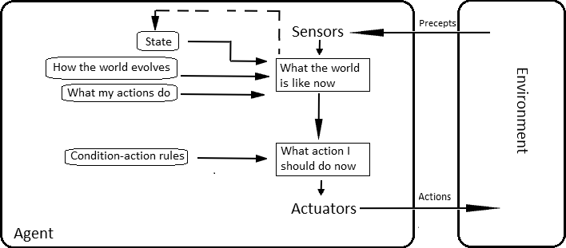

1. **Goal-based agents** – select their action based off of a goal
   1. Also uses characteristics of model-based agent (knowledge of the environment and the effects of its actions on the environment)
   2. This is different from the condition-action rules of the first two types of agent. Goal-based agents consider the future:
      1. “What will happen if I do xyz…?”
      2. “Will that make me happy?” (satisfy/get closer to my goal)

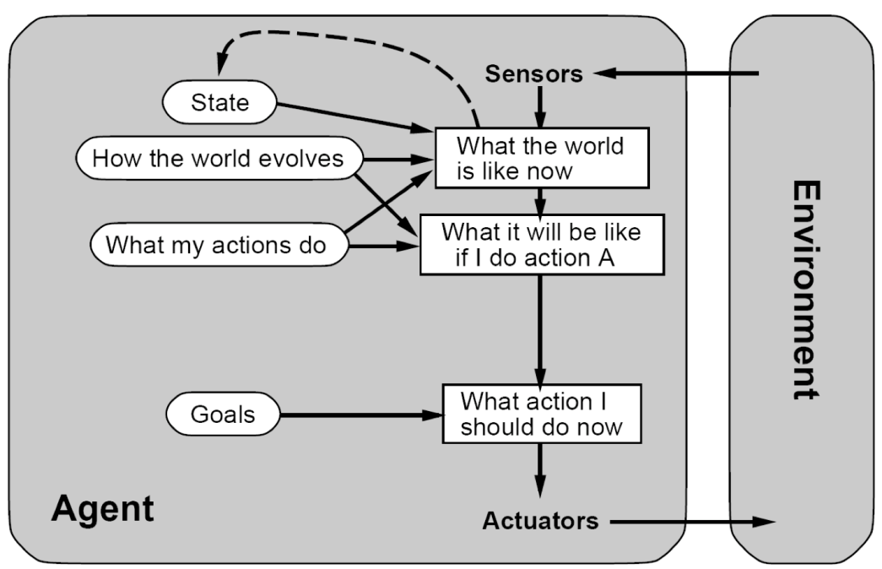

1. **Utility-based agents** – select behaviors that maximize utility (utility is the AI word for happiness)
   1. Goals alone aren’t enough to generate high-quality behavior in most environments.
      1. Think about a Taxi driver who is concerned only with the goal of getting to its destination
   2. Goals are great, but they don’t allow for any gray areas – only “happy” or “unhappy”
   3. **Utility Function** – an internalization of the performance measure. How well the agent thinks he’s doing

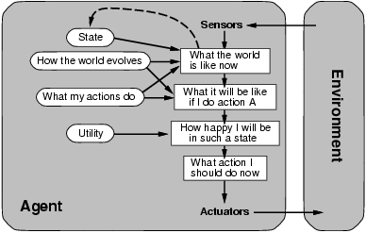

1. Conclusion
   1. So what…..? This is all common sense, but it’s important to formalize terms to better explain some types of agents. This also makes it easier for us to make more complex agents if we have clearly established terms.
   2. Notice that as we talked about the four types of agent, they got more and more complex and built on each other.